Logcat function appear

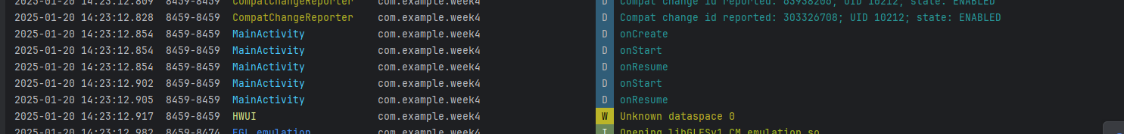

Second Activity

The shopping app

Adding the item into it :

